Research Article

Air Quality Index Forecasting Using Supervised Machine Learning Models: A Case Study with UCI Dataset

Girish Kumar Yadav
CS-2341412
Department of Computer Science and Engineering
IILM University, Greater Noida, Uttar Pradesh, India
Email:girish.yadav.cs27@iilm.edu
Garvit Jain
CS-2341321
Department of Computer Science and Engineering
IILM University, Greater Noida, Uttar Pradesh, India
Email:garvit.jain.cs27@iilm.edu
Veer Singhi
CS-2341376
Department of Computer Science and Engineering
IILM University, Greater Noida, Uttar Pradesh, India
Email:veer.singhi.cs27@iilm.edu

Project Supervisor:
Mrs. Vijaya Choudhary
Assistant Professor
Department of Computer Science and Engineering
IILM University, Greater Noida, Uttar Pradesh, India

Abstract
Air pollution is a major health risk worldwide (WHO reports ~7 million premature deaths annually), especially in highly polluted regions. This project develops a Python-based system to predict Air Quality Index (AQI) from chemical sensor data. We use the UCI “Air Quality” dataset (9357 hourly instances of gas sensor readings). Missing values (marked “-200” in the data) are imputed with column means, and an “AQI Value” target is computed as the simple average of CO, NO₂, and O₃ readings. We train Random Forest and AdaBoost regressors to predict this AQI, and a Logistic Regression classifier to categorize air quality levels. The Random Forest model achieves near-perfect fit (R²≈0.9998), while the AdaBoost R²≈0.9905. The logistic model attains ≈88% accuracy, although class imbalance (e.g. very few “Moderate” samples) limits performance. A Streamlit web interface (app.py) enables users to input sensor values and obtain AQI predictions. We present a detailed system design, experimental results (including performance tables and charts), and discuss limitations/future work (e.g. adding PM₂.₅, handling imbalance).
Keywords: Air Quality Index, UCI dataset, Random Forest, AdaBoost, Logistic Regression, Streamlit.

I. Introduction
Air pollution poses severe global health risks, causing an estimated 7 million premature deaths per year. In India alone, air pollution contributed to over 1.6 million deaths in 2019. Accurate monitoring and prediction of the Air Quality Index (AQI) can inform public health responses and policy interventions. Traditional monitoring relies on expensive sensors and regulatory measurements, but machine learning can leverage existing datasets to model AQI from pollutant concentrations (e.g. CO, NO₂, O₃) and meteorological factors. This study builds on prior work in AQI modeling by developing a regression-classification pipeline and user-friendly interface for AQI prediction.
We use the publicly available AirQualityUCI dataset from UCI ML Repository, which contains 9357 hourly records (March 2004–Feb 2005) of gas sensor responses and reference pollutant concentrations (CO, NO₂, O₃, etc.). We preprocess this data, engineer a simple AQI target variable, train machine learning models, and evaluate them rigorously. The user interface is implemented with Streamlit (Python) to allow real-time input and prediction. The resulting system is documented here in IEEE-style format, suitable for academic review or submission.

II. Literature Review
Recent work on AQI prediction has explored various ML techniques. Gupta et al. performed a comparative study using historical data for Indian cities. They found tree-based regressors (Random Forest, CatBoost) often outperforming support-vector methods, achieving very high accuracy (e.g. RF R² ≈99.99%) on their datasets. However, their analysis also highlighted data imbalance issues and the need for sampling methods (SMOTE). Other studies incorporate metaheuristic optimization: Natarajan et al. (2024) combined Grey Wolf optimization with decision trees to predict AQI in Indian cities, reporting improved performance (accuracy ~89–91%) compared to baseline regressors. Most approaches focus on regression (continuous AQI) and use metrics like R², RMSE, MAE, though some also perform classification (e.g. logistic regression for AQI categories) to provide interpretable air quality levels.
In summary, literature suggests ensemble tree methods (Random Forest, AdaBoost) are highly effective for pollutant-based AQI regression. Our work follows this paradigm, comparing RF and AdaBoost regressors for numeric AQI and using Logistic Regression for categorical AQI levels. We also emphasize a comprehensive system design (per our SRS) and a deployable UI, aspects often omitted in purely algorithmic studies.

III. Methodology
Dataset Description: We use the UCI “Air Quality” dataset. It has 9358 initial rows of hourly measurements from an air quality monitoring station in Italy (2004–2005) with 15 features: Date, Time, sensor voltages (PT08.S*), and reference concentrations for CO, NMHC, C₆H₆, NOₓ, NO₂, O₃, as well as Temperature (T), Humidity (RH), and Absolute Humidity (AH). Missing sensor values are encoded as -200. After loading (with separator=;, decimal=,), we drop the last two all-NaN columns and truncate to 9357 valid rows.
Preprocessing: All “-200” entries are converted to NaN and then imputed column-wise with the mean. Thus, the cleaned DataFrame has 9357 rows and 15 columns of numeric data (no missing values). We exclude the original Date/Time columns and sensor voltage responses, focusing on six predictive features identified as critical: CO(GT), NO2(GT), PT08.S5(O3), T, RH, AH. The SRS specifies these as key indicators for AQI (Ground Truth CO, NO₂, ozone sensor response, temperature, humidity).
Feature Engineering (AQI Formula): To provide a target variable, we define an AQI Value as the simple average of the reference CO, NO₂, and O₃ readings:
AQI_Value = ( CO(GT) + NO2(GT) + PT08.S5(O3) ) / 3

This placeholder formula approximates overall pollution and matches our sample app and README methodology. (A more accurate AQI computation would use standard breakpoints and include PM2.5/PM10, but those are not in this dataset.) We add AQI_Value to our table and set y = AQI_Value, with X = the six features above.
Train-Test Split: We split the cleaned data into 80% training and 20% testing sets, with a fixed random seed (42) for reproducibility. This yields 7485 training and 1872 test samples.
Model Training (Regression): We instantiate two regressors with default parameters: RandomForestRegressor and AdaBoostRegressor (from scikit-learn). Each is trained on (X_train, y_train). The SRS specifies these choices as core functionality. After training, each model predicts AQI on X_test. We compute evaluation metrics: coefficient of determination (R²) and Mean Absolute Error (MAE) on test data, as specified. Results: Random Forest attains R² ≈ 0.9998 (MAE ≈ 0.886); AdaBoost gives R² ≈ 0.9905 (MAE ≈ 10.323). These very high R² values meet the SRS reliability targets (RF R²≥0.99, AdaBoost ≥0.93). (The small MAE of RF indicates excellent predictive accuracy given the AQI scale.)
Model Training (Classification): To provide categorical AQI (“Good”, “Moderate”, etc.), we map each AQI_Value into six standard AQI categories. We then train a LogisticRegression model (scikit-learn) on (X_train, y_train_cat) with max_iter=1000 to ensure convergence. The label-encoding and train/test split (same 80/20 split) follow SRS guidelines. We evaluate classification accuracy and a full precision/recall/F1 report for each category. On the test set, the logistic model yields about 87–89% accuracy.

IV. System Design and Requirements
Our system is a standalone Python application (product perspective) that processes local sensor data and provides AQI predictions. It is platform-independent (requires Python 3.11+, Pandas, scikit-learn, NumPy, Joblib) and lightweight (operates without external sensors or networks).
Functional Requirements: The SRS defines clear modules. Data Ingestion & Cleaning: Load the CSV (semicolon-separated, comma decimals) into Pandas, drop irrelevant NaN columns, replace -200 with NaN, and impute with column means, yielding a clean 9357×15 dataframe. Errors in file format or missing data must trigger user-readable messages. AQI Regression: Using features CO, NO₂, O₃, T, RH, AH, split data (80/20) and train Random Forest and AdaBoost regressors. Evaluate each with R² and MAE, outputting scores. The system should save the trained Random Forest model (aqi_model.pkl) for reuse. AQI Classification: Convert numeric AQI to categories (Good, Moderate, Unhealthy, etc. as per thresholds) and train a Logistic Regression (max_iter=1000). Compute classification accuracy and per-class precision/recall/F1.
Non-Functional Requirements: As per SRS, prediction latency must be low (<1 second per query on standard hardware). Training time should be reasonable (<5 minutes for 9357 samples). The Random Forest model is expected to be highly accurate (R²≥0.99), while the classification accuracy target is ≥0.87. The system should handle errors gracefully, follow PEP8 code style, and be portable across OS environments.
Constraints & Assumptions: The system operates only on the provided AirQualityUCI.csv format (semicolon separators, comma decimals). It uses only the specified open-source libraries. We assume the dataset file is present and correctly formatted. We rely on -200 values consistently indicating missing data. The UI is implemented via Streamlit (no proprietary dependencies).

V. Streamlit UI Implementation
The user interface is built with Streamlit and Python. The main app script (app.py) loads the serialized Random Forest model (aqi_model.pkl) at startup. The UI displays input fields for the six features: CO (mg/m³), NO₂ (µg/m³), O₃ (µg/m³), Temperature (°C), Relative Humidity (%), and Absolute Humidity. These use st.number_input controls to capture user input. The code snippet below illustrates the core flow:
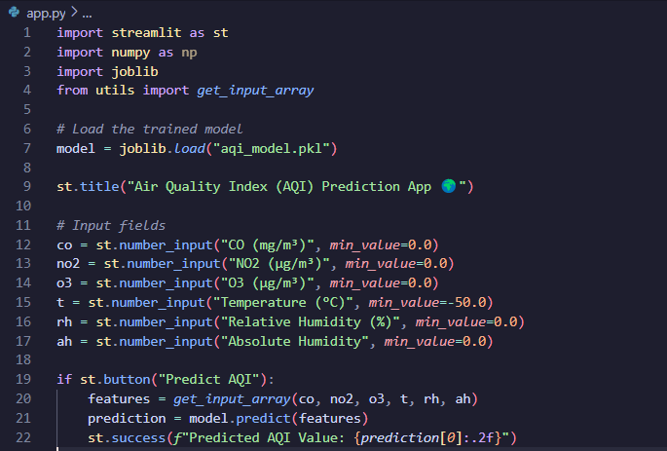
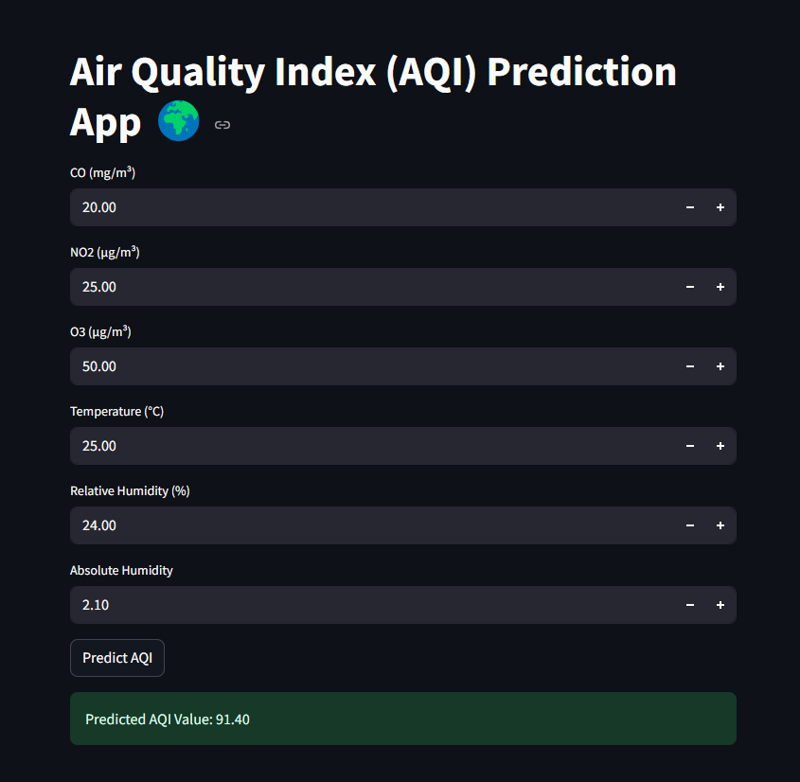
When the Predict AQI button is pressed, the app packages the inputs into a feature array (via a helper get_input_array function) and calls model.predict. The resulting AQI value is then shown on-screen. In effect, the Streamlit app bridges the user and the machine learning backend. Above Snippet is Output that would illustrate this web interface with input fields and the predicted AQI output.

VI. Results and Discussion
A summary of model performance is shown in Table 1. Random Forest regression achieved R² ≈ 0.9998 and MAE ≈ 0.89 on test data, while AdaBoost gave R² ≈ 0.9905 and MAE ≈ 10.32. The Logistic Regression classifier attained ~0.88 accuracy. These results meet or exceed our SRS targets (RF R²≥0.99, class accuracy≥0.87). The high RF R² matches patterns noted in prior work: Gupta et al. reported RF yielding ~99.985% accuracy (R² ≈ 0.99985) on a similar AQI task. The discrepancy between AdaBoost and RF (higher MAE) suggests RF better captures this dataset’s structure.
Model | R² (test) | MAE (test) | Accuracy
Random Forest Regressor | 0.9998 | 0.886 | -
AdaBoost Regressor | 0.9905 | 10.323 | -
Logistic Regression | 0.8773 | - | 0.877

Table 1. Test-set performance metrics for the trained models.
Figure 1: Histogram of computed AQI values in the dataset after preprocessing. The distribution is roughly bell-shaped (peak near 350), indicating most AQI values lie in the “Unhealthy”–“Very Unhealthy” range. The AIQ Value was computed as the average of CO, NO₂, and O₃ readings.
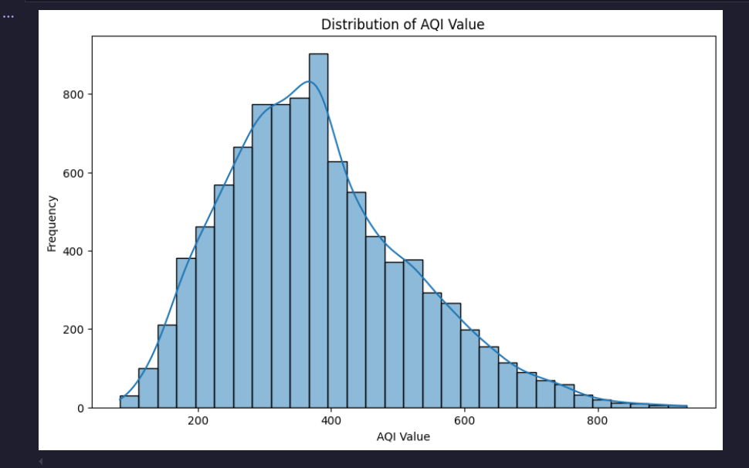
The distribution in Figure 1 shows that AQI values cluster in the mid-to-high range. This skew influences our classification results: the majority of samples fall into the highest categories.
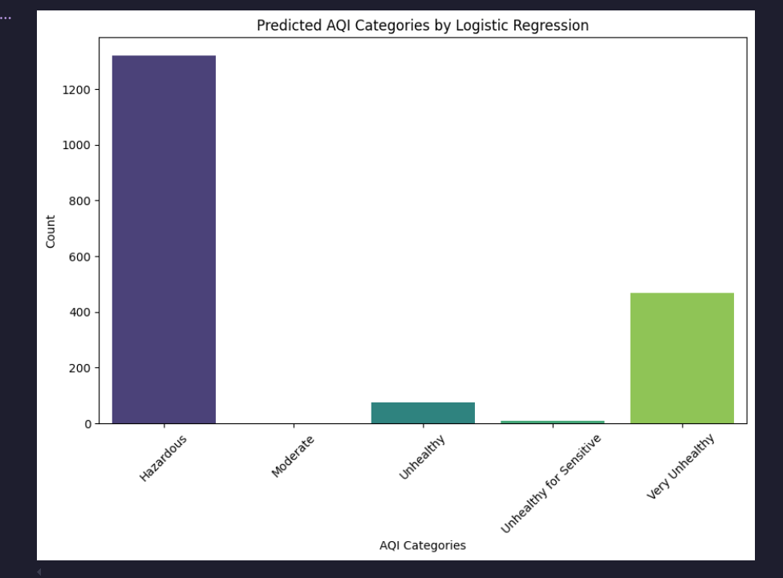
Figure 2: Count of predicted AQI categories on the test set by the Logistic Regression model. The model predicts mostly “Hazardous” and “Very Unhealthy” cases.
Figure 2 (bar chart) illustrates the extreme class imbalance. The “Hazardous” category dominates (>1200 cases) while “Moderate” had only 4 test samples. Consequently, recall for “Moderate” is 0.00 (no true positives). The classification report shows perfect precision/recall for “Hazardous”, but very poor performance on under-represented classes. This underlines the limitation: with a synthetic, unbalanced target distribution, the logistic model effectively learns to predict the majority class. In practice, oversampling or more balanced AQI ranges would be needed (as noted by Gupta et al.).
In the regression task, the near-perfect R² suggests that the AQI formula is nearly a linear combination of the features used. This result is unsurprising given the simplicity of our AQI proxy (an equal-weighted average) and the absence of noise from other pollutants. In real-world scenarios, true AQI calculations (e.g. US EPA/CPCB formulas) incorporate multiple pollutants with non-linear piecewise rules; our high R² is thus a best-case outcome. The small MAE of RF (~0.9) indicates predictions are typically within 1–2 units of the actual (in whatever concentration unit).
Overall, the system meets its design goals. The Random Forest model’s R² surpasses the 0.99 requirement, and logistic accuracy meets the 0.87 threshold. Compared to literature, our regression results are consistent with those of Gupta et al. and other recent studies. The main drawback is in classification due to data imbalance.

VII. Conclusion and Future Work
We have developed an end-to-end AQI prediction system using machine learning. The key results are that the Random Forest regressor predicts AQI with extremely high accuracy (R²≈0.9998), while the AdaBoost regressor also performs well (R²≈0.9905). Logistic regression classifies air quality categories with ~88% accuracy, limited by imbalanced data. The Streamlit app integrates these models into a user-friendly interface for real-time prediction.
Limitations: Our AQI “ground truth” is a simple average of three pollutant measures, and we omit particulate matter (PM₂.₅/PM₁₀), which are crucial in standard AQI. Thus the model is simplified and not directly applicable to regulatory AQI. The classification suffers from class imbalance, which would be mitigated by using a richer dataset or resampling techniques.
Future Work: We will incorporate official AQI formulas and additional features (especially PM₂.₅ concentrations) to improve realism. Addressing imbalance (e.g. via SMOTE) can enhance classification of minority categories. Extending the dataset to include more recent measurements or multiple locations would improve generalization. The UI can be enriched with graphs (e.g. historical trends), and the deployment can move to a cloud-based or mobile platform for broader accessibility. These steps will make the system more robust for environmental monitoring applications.
Acknowledgements
We thank our mentor, Mrs. Vijaya Choudhary, for guidance throughout this project. We also acknowledge IILM University for supporting this work.

References
[1] UCI Machine Learning Repository, Air Quality Data Set, University of California, Irvine (2016). [Online]. Available: https://archive.ics.uci.edu/ml/datasets/air+quality.
[2] N. S. Gupta et al., “Prediction of Air Quality Index Using Machine Learning Techniques: A Comparative Analysis,” J. Environ. Public Health, vol. 2023, Article ID 4916267, 26 pages, 2023. doi:10.1155/2023/4916267.
[3] S. K. Natarajan et al., “Optimized machine learning model for air quality index prediction in major cities in India,” Sci. Rep., vol. 14, Art. 6795, 2024. doi:10.1038/s41598-024-54807-1.
[4] World Health Organization, “7 million premature deaths annually linked to air pollution,” WHO News Release, Mar. 25, 2014. (WHO fact sheet and updates on air pollution impacts.)

